**KENYA NATIONAL STATISTICAL SOCIETY**

**(KNSS)**

**Certificate of Membership**

This is to certify that

**Robin Lokoyan**

is a Member No**. *KNSS-00199*** (Ordinary) of the Kenya National Statistical Society in accordance with Article 3 of the Society’s charter.

The above mentioned person is authorized to promote KNSS activities according to the Society’s Constitution and Rules.

Signed this day: February 25th 2018

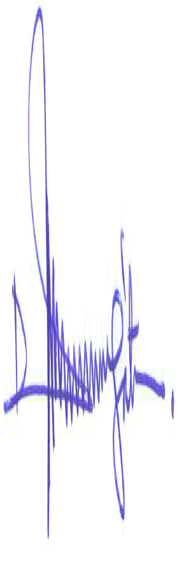 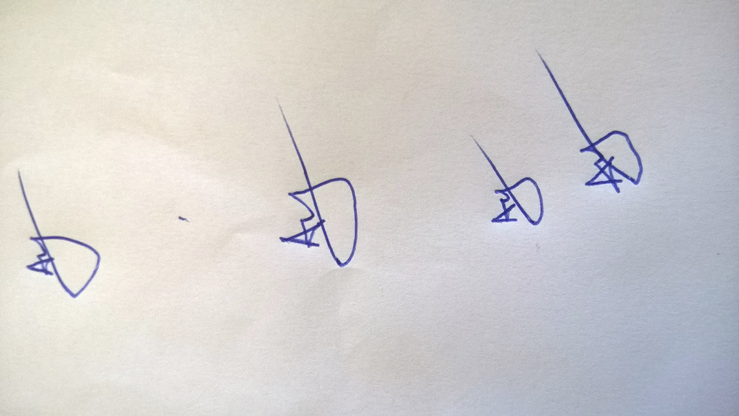

 **Dr. Joseph K. Mung’atu, PhD. DR. Aggrey Adem, PhD.**

The Chairman, KNSS The Secretary General, KNSS