**AGENDA FOR THE KNSS VIRTUAL SPECIAL GENERAL MEETING TO BE HELD ON FRIDAY 21ST AUGUST 2020 AT 10AM**

**Agenda**

1. Filing of returns
2. Activities of the Society

**Signed: 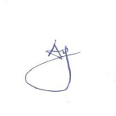 Date 29th July 2020**

**Dr. Aggrey Adem**

**Secretary General**